**Function circle.png**

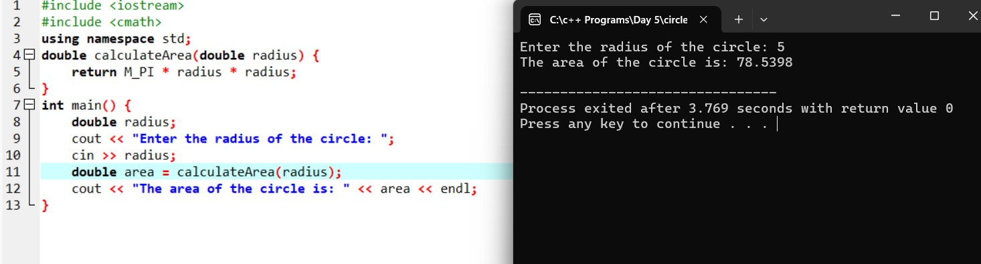

**Function palindrome.png**

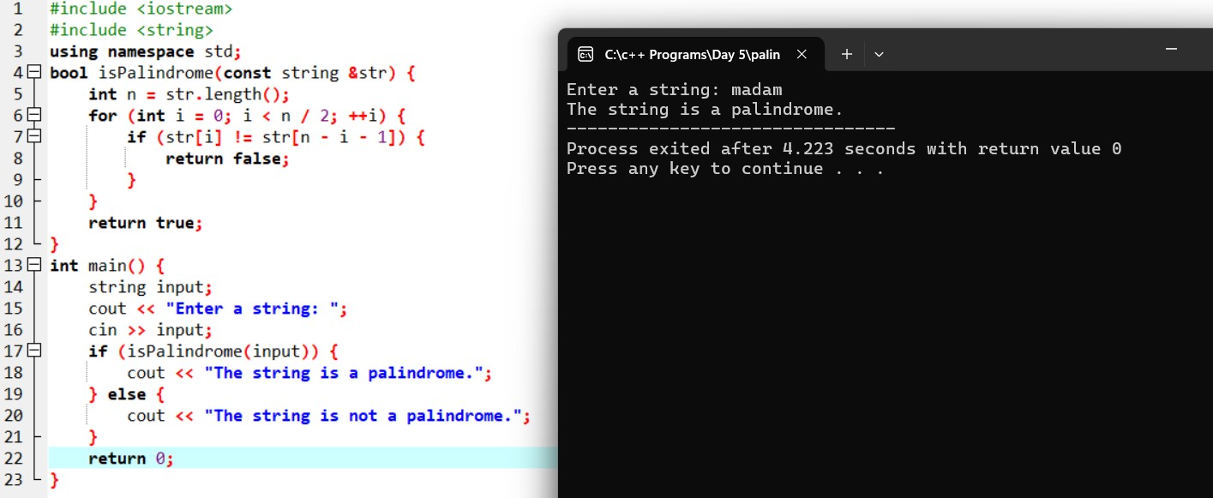

**Function string.png**

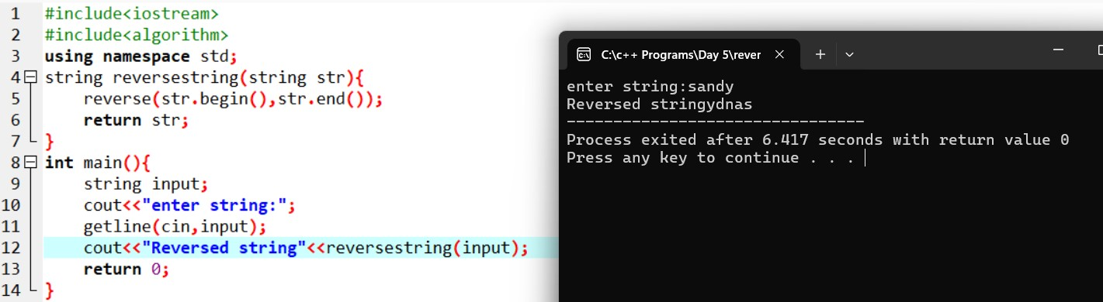

**function Celsius to Farenheit.png**

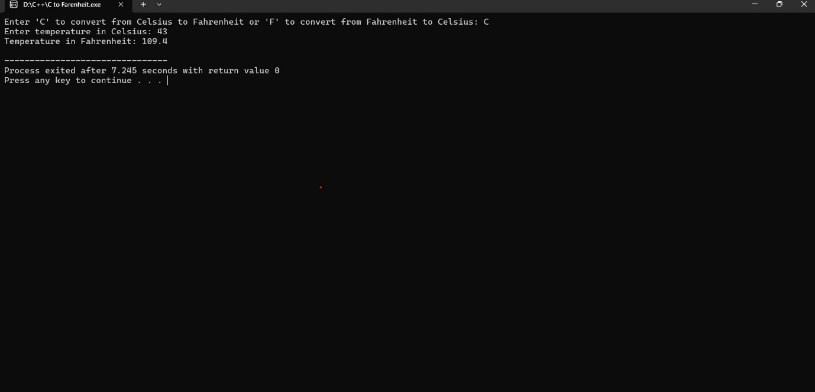

**function GCD.png**

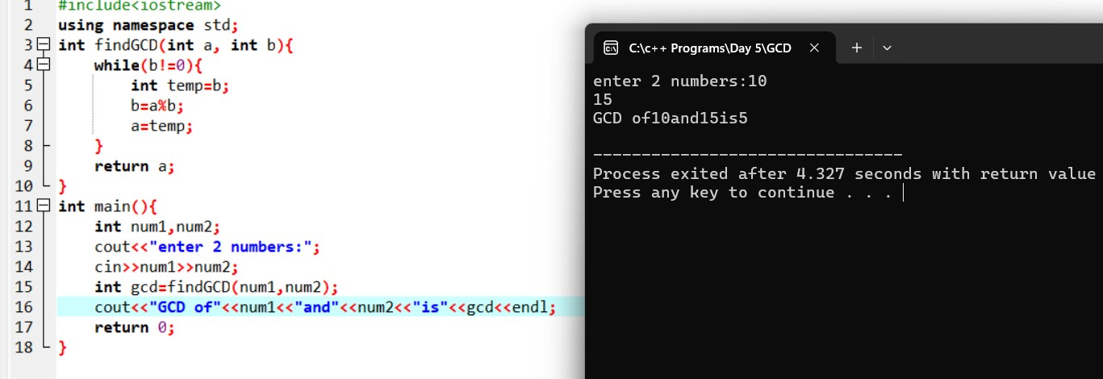

**function count.png**

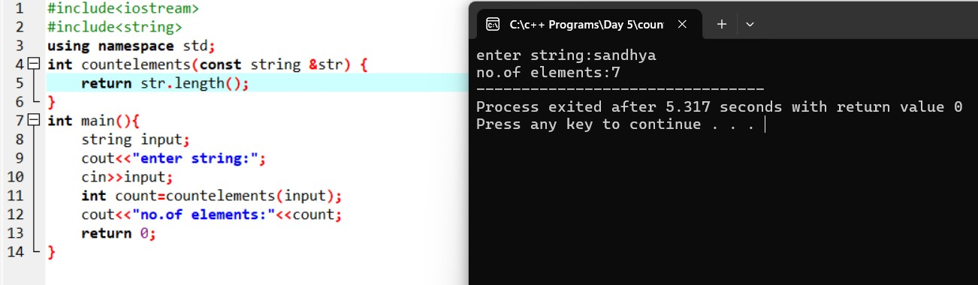

**function fact.png**

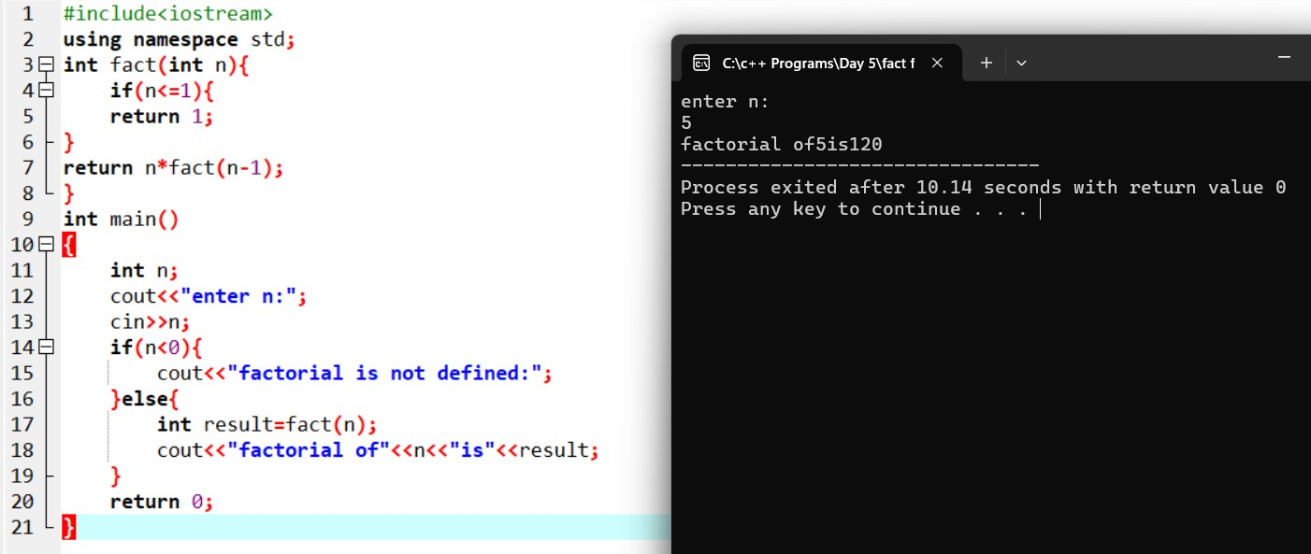

**function max min.png**

